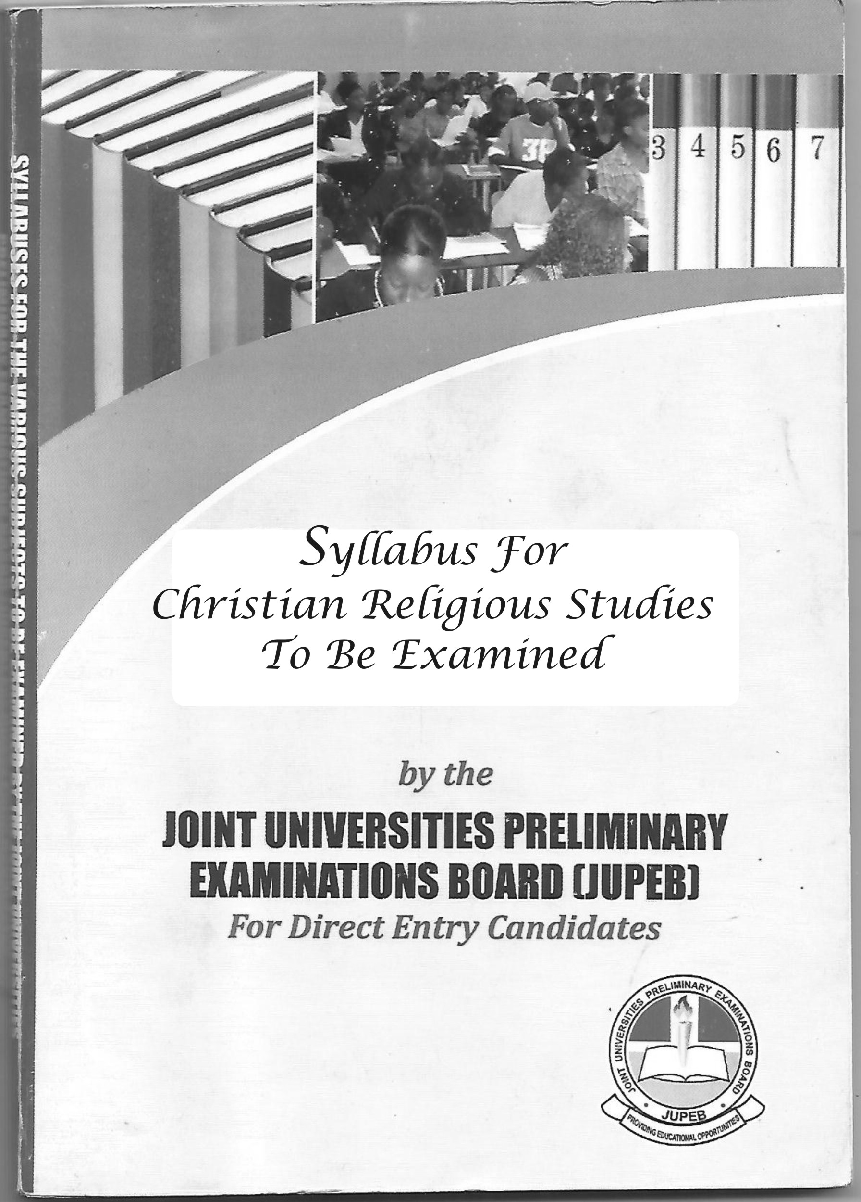
www.jupeb.com.ng >>> JUPEB Foundation Programme Admission, Registration And Info Website
SYLLABUS FOR ART – J121

CHRISTIAN RELIGIOUS STUDIES (CRS)
1.0 General Objectives:
At the end of the study of the course in Christian Religious Studies (CRS), candidates should be able to:
i. Explain how the Old Testament and the New Testament came into existence;
ii. Enumerate the outstanding Kings and Prophets of Israel during the monarchy and itemize the contributions of each to the religious, social and political development of Israel;
iii. Trace the history and development of Christianity in West Africa with particular reference to Sierra Leone, Ghana and Nigeria;
iv. Discuss the relationship between religion and society paying attention to such personality and human values like dignity, security, power and prestige based on basic rights and duties and religious sanctions;
v. Highlight Christian response to specific controversy societal challenges, stressing effects of such on the individual and the society and proffer the way forward.

2.0 COURSES
FIRST SEMESTER
CRS 001: Old Testament Studies: History and Religion of Israel and Judah (3 units)
CRS 002: New Testament Studies: The Synoptic Gospels (3 units)

SECOND SEMESTER
CRS 003: History of Christianity in West Africa (3 Units)
CRS 004: Religion and Society (3 Units)

3.0 DETAILED SYLLABUS
FIRST SEMESTER
CRS 001: OLD TESTAMENT STUDIES: HISTORY
AND RELIGION OF ISRAEL AND JUDAH (3 UNITS)
Course Description: This course critically examines the composition of the Holy Bible as a unique document; nature of Old Testament history with particular attention to the rise of the monarch and the North – South divisions of the States of Israel. In addition, the course appraises the rise of prophecy in Israel particularly the themes raised by Prophet Isaiah, Hosea and Amos.

Specific Objectives: At the end of the study of this course, candidates should be able to:
i. Analyze the process of canonization of the OT and highlight the genre of literature
ii. Discuss the issues involved in the documentary hypothesis
iii. Examine the factors that gave birth to the Monarch in Israel and mention the contributions of notable Kings to the religious and socio-political development of the land.
iv. Give a detailed description of the events that led to the Divided Kingdom
v. Appraise prophecy in Israel and the influence of Prophet Isaiah, Hosea and Amos, the relevance of the themes in Nation building (particularly in Nigeria) should be pointed out.

Detailed Syllabus:
a. Formation and Composition of the Old Testament
b. The Documentary Hypotheses
c. The Rise of Monarchy in Israel
d. The Divided Kingdom and the Exile(s)
e. The Rise of Prophecy in Israel with particular reference to the Themes raised by Isaiah (Holiness), Hosea (Love) and Amos (Justice).

CRS 002: NEW TESTAMENT STUDIES:
THE SYNOPTIC GOSPELS (3 Units)
Course Description: The course studies the synopsis, materials and canonization of the New Testament with particular emphasis on the birth of the Synoptic Gospels, the Synoptic Problem and the current proposed solution and Modern criticism of the N.T. It also probes into the literature and theology of the three Synoptic Gospels (Matthew, Mark and Luke) and concludes with a comparative study of the Synoptics with the Gospel of John.

Specific Objectives: At the end of this course, candidates should be able to:
i. Give the synopsis of the N.T. literature
ii. Clarify the term ‘Synoptic’ and state why the Gospels are so called
iii. Examine the Synoptic Problem and proffer solution
iv. Give a comprehensive exposition of the Modern Criticism of the Synopticcs and clearly identify the aims of the critics
v. Discuss the Literature and Theology of the Synoptic Gospels.
vi. Compare and contrast the Synoptic Gospels with the Gospel of John.

Detailed Syllabus:
a. The synopsis, materials and the canonization of the New Testament
b. The Synoptic Gospels
c. The Synoptic Problems
d. Modern Criticism of the New Testament
e. The Literature (authorship, date, purpose, and characteristics) and Theology (doctrinal emphasis such as Son of Man, Messianic Secrecy, Kingdom of God, etc) of the three Synoptic Gospels – Mathew, Mark and Luke
f. A comparative study of the Synoptics with the Gospel of John

CRS 003: HISTORY OF CHRISTIANITY IN WEST AFRICA (3 Units)

Course Description: The course extensively highlights the efforts made at Christianizing West Africa, particularly the planting of Christianity in Sierra Leone, Ghana and Nigeria. It also consider the rise and expansion of the African Independent Churches, Pentecostalism and the issues around the proliferation of Churches.

Specific Objectives: It is hoped that by the time this course ends, candidates should be able to:
i. Narrate the establishment of Christianity in Sierra Leone with emphasis on the specific role of concerned groups such s the Abolitionists and the ex-slaves
ii. Discuss how Christianity was introduced to Ghana and Nigeria
iii. Highlight the influence of Christianity on the host communities
iv. Discuss the rise, characteristics and expansion of the African Independent Churches
v. Examine Pentecostalism and the rise of New Religious Movements within the Church in Nigeria
vi. Assess the causes and impacts of proliferation of churches in Nigeria.

Detailed Syllabus:
a. The establishment of Christianity in Sierra Leone
b. The planting of Christianity in Ghana and Nigeria
c. The influence of Christianity on selected West African Communities
d. The Rise of African Independent Churches
e. Pentecostalism in Nigeria
f. The Proliferation of Churches today

CRS 004: RELIGION AND SOCIETY (3 Units)
Course Description: The course explores the relationship between Religion and the contemporary society; sociological theories and functions of religion; personality and human values and the Christian response to contemporary issues.

Specific Objectives: At the end of this course, candidates should be able to:
i. Clarify the terms ‘religion’ and ‘society’ and discuss how they relate
ii. List and appraise the various sociological theories of religion
iii. Discuss how religiosity is measured
iv. State the place of religion in the society
v. Examine what the Christian response should be to contemporary issues.

Detailed Syllabus:
a. The Relationship between Religion and Society
b. Sociological Theories of Religion
c. Measures of Religiosity
d. Functions of Religion
e. Religion and Conflict Resolution
f. Personality and Human values, e.g. dignity, security, power and prestige based on basic rights, duties and religious sanctions.
g. Christian Response to Contemporary Issues like Gender, Drug Abuse, Cultism, HIV/AIDS Epidemic, Homosexuality, Euthanasia, Corruption, etc.

4.0 Suggested Reading List
1. Ajayi, J.F.A (1965). Christian Mission in Nigeria 1841 – 1891. London Longmans
2. Ayandele, E.A. (1970). The Missionary Impact in Modern Nigeria, 1840 – 1947. London: Frank Class
3. Ayegboyin, I.D. (2004). The Synoptics. Ibadan: Daystar
4. Barclay, W. (1981) The Gospel of Mark. Edinburgh: Saint Andrews Press
5. Barclay, W. (1981) The Gospel of Luke. Edinburgh: Saint Andrews Press
6. Barclay, W. (1981) The Gospel of Matthew. Edinburgh: Saint Andrews Press
7. Campbell, D.B.J. (1983). The Synoptic Gospels. London: John Murray
8. Ceresco, A.R. (1992). Introduction to the Old Testament. Mary Knoll: Orbis Books
9. Chenimuya, C.C. (2008). Sociology of Religion. Lagos: T-Excel Publishers.
10. Christiano, K.J. et al, (2001). Sociology of Religion: Contemporary Development. USA: Alta Mira Press
11. Douglas, J.D. et al,, {Eds} (1992). New Bible Dictionary Leicester: IVP.
12. Dzurgba, A. (2000). The Sociology of Religion. Ibadan: Department of Adult Education, University of Ibadan, Ibadan.
13. Espisto, J.l. et al, (2006) World Religions Today. Oxford: OUP.
14. Jowitt, D. (2010). Christianity: A Concise History, Ibadan: Kraft Books Ltd
15. Hauer, C.E. & Young, W.A. (1993). An Introduction to the Bible. Englewood Cliffs: Prentice Hall.
16. Idahosa, M.C.A. (2004). Brief History of the Catholic Church. Lagos: EHJ
17. Isichei, E.A. (1995). History of Christianity in Africa. London: SPCK.
18. Kalu, O.U. {Ed.} (1978). Christianity in West Africa: The Nigerian Story. Ibadan: Daystar Press
19. Oguntoyinbo-Atere, M.I. (2002). New Testament Theology. Ibadan External Studies Programme Series, Dept. of Adult Education, University of Ibadan.
20. Omoyajowo, J.A. {Ed.} (1995). Makers of the Church in Nigeria, 1842 – 1947. Lagos: CSS
21. Oshitelu, G.A. (2002). Expansion of Christianity in West Africa. Abeokuta: Visual Resources Pub.
22. Falk, P. (1997). The Growth of the Church in Africa. Jos: ACTS.
23. Uffenheimer, B. (1999). Early Prophecy in Israel. Jerusalem: The Magnum Press.
24. Walton, R.C. {Ed.} (1976). A Source Book of the Bible for Teachers. London: SCM
25. The Holy Bible (RSV)
www.jupeb.com.ng >>> JUPEB Foundation Programme Admission, Registration And Info Website

