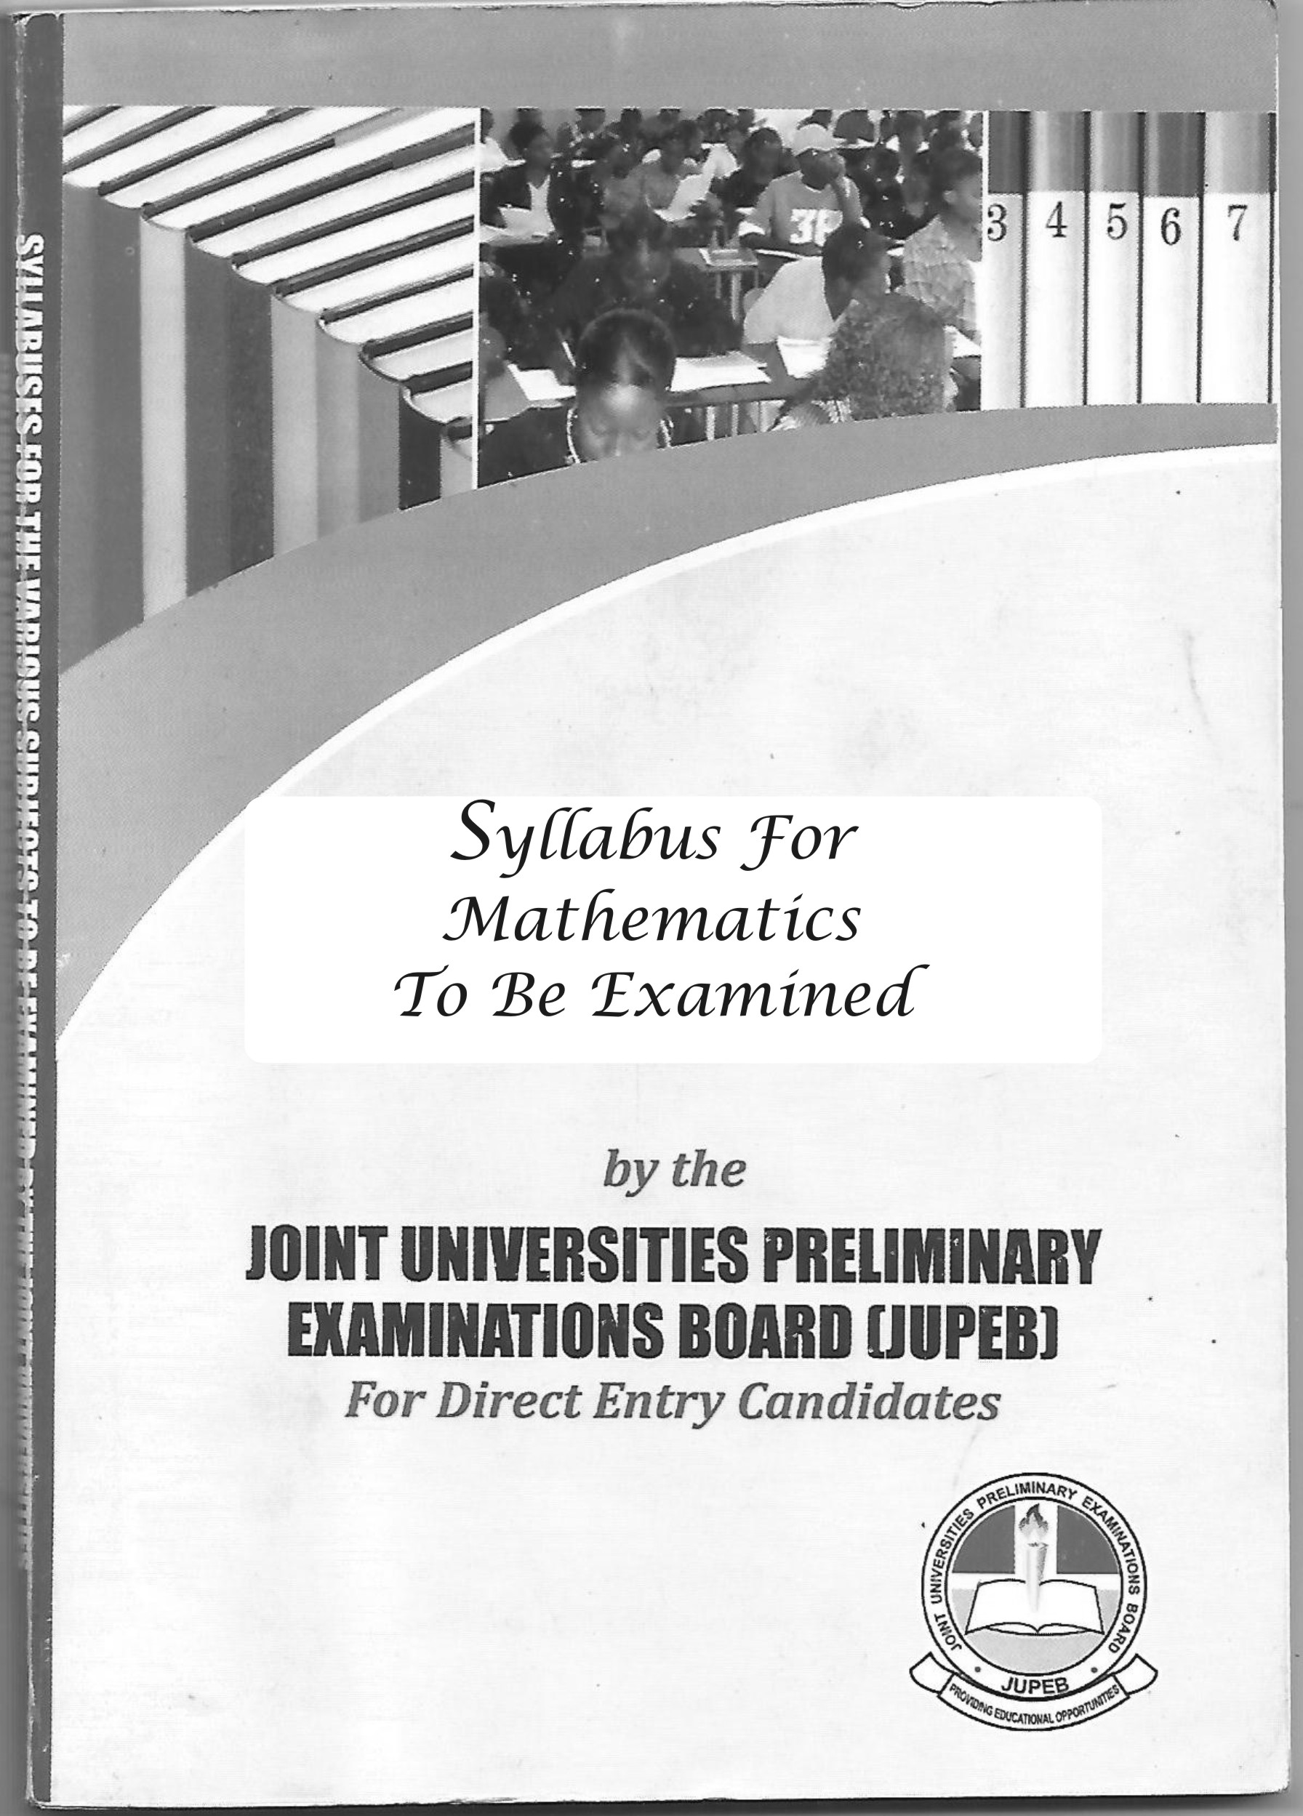
SYLLABUS FOR SCI – J154
MATHEMATICS
www.jupeb.com.ng >>> JUPEB Foundation Programme Admission, Registration And Info Website

General Objectives

At the end of this programme, the candidates should be able to:
1. Identify and solve problems in general algebra which include set, real number system,
trigonometry, complex numbers, and coordinate geometry
2. Solve problems in calculus which involve the different rules of differentiation and differentiation of various functions. Solve problems on ordinary differential equations of first and second order using different techniques
3. Manipulate the problems in Mechanics through the understanding of vectors, kinematics of motion, Forces, Newtonian laws, inclined plane, motion of particles in a plane, equilibrium of rigid bodies
4. Evaluate the general analysis of statistical data, deal with random variables using different probability density functions such as Bernoulli, Binomial, geometric and Poison random variables. Model data using the Normal distribution and the use of the normal standard tables.

FIRST SEMESTER COURSE
MAT 001: Advanced Pure Mathematics 3 Units
MAT 002: Calculus 3 Units

SECOND SEMESTER COURSE
MAT 003: Applied Mathematics 3 Units
MAT 004: statistics 3 Units

MAT 001: Advanced Pure Mathematics 3 Units
Specific Objectives
At the end of this course, the candidates should be able to:
1. Manipulate in all ramification the different set problems
2. Identify and perform operations with the number system
3. Solve problems on circular functions
4. Use trigonometric identities and apply the concept of trigonometry in solving practical problems

Course Content
Algebra: Elementary set theory, subset, union, intersection, complements, Venn Diagram, mappings, polynomials. Theory of quadratic equations, Binomial theorem, matrices and determinants, Partial fractions, inequalities: linear, quadratic and graphical solution, Absolute value and intervals.
Real Numbers: Integer, rational and irrational numbers, Mathematical induction, real sequences, and series, Binary operations
Trigonometry: Circular measure, trigonometric functions of angles of any magnitude and trigonometry formulae, solution of transcendental equation, Graphs of trigonometry functions.
Complex numbers: Basic complex numbers, Algebra of complex numbers, the Argand diagram, De-Moivres theorem (nth root of unity), complex numbers in polar form, loci problems.
Coordinate Geometry: The straight line, circles, parabola, ellipse, hyperbola, tangents and normal.

MAT 002: CALCULUS 3 Units

Specific Objectives
At the end of this course, the candidates should be able to:
1. Solve problems on limit
2. Differentiate various functions including algebraic logarithmic, exponential, and implicit functions
3. Apply the techniques of differentiation in solving practical problems
4. Use the technique of integration in solving practical problems

Course content
Differentiation: Functions of a real variable, graphs, limits and notion of continuity, Differentiation of algebraic functions, trigonometric functions, composites function, chain rule, and quotient rule, higher order derivatives, derivative of implicit and parametric functions.
Applications: Rectilinear motions, tangents, and normal’s to a curve, maximum and minimum, rate of change and curve sketching, Maclaurin and Taylor series
Exponential functions: The graph of exponential function (a^{x}), the limit and derivative of the function (a^{x}), the exponential function e^{x}, the graph, limit and derivative of the exponential function e^{x}
Logarithm functions: The relationship between logarithm and indices, change of base, the natural logarithm, the relationship between logarithmic and exponential functions, the graph, limit and derivatives of the logarithmic function log_{e}x, the derivative of the logarithmic function.
Integration: Integration as inverse of differentiation, definite integral, techniques of integrations, improper integrals
Application: Area, Volumes, and moment of inertial. Numerical methods of integrations: Trapezoidal and Simpson rules.
Differential Equations: Formulation of simple first order differential equations, solution when the variables are separable, solution when the equation is homogenous and solution when the equation is linear or non-linear, use of an initial condition
Second order differential equation: Homogenous second order differential equations with constant coefficients
Geometric applications: the exponential growth and decay problems.

MAT 003: APPLIED MATHEMATICS 3 UNITS

Specific Objectives
At the end of this course, the candidates should be able to:
1. Evaluate the various operations of vectors
2. Solve problems involving motion of vectors in a straight line
3. State and apply the Newton’s law of motions
4. Solve problems of particle on an inclined plane
5. Solve problems of forces in equilibrium and equilibrium of rigid bodies

Course content
Vectors: Scalar and vector quantities, types of vectors, representation and naming of vectors; vector algebra: addition, subtraction and scalar multiplication, commutative and associativity, linear dependence and co-linearity, vector equation of lines and planes, application to geometry, Vector in three dimensions: the rectangular unit vectors i, j and k, representation of vectors in terms of rectangular coordinates, scalar and vector functions, differentiation of vector functions, integration of vector functions.
Kinematics of motion in a straight line: position vector, speed, velocity and acceleration, units; Rectilinear motion: rectilinear motion with uniform acceleration, vertical motion under gravity, graphical methods; motion in a plane: rectangular component of velocity and acceleration, resultant velocity, relative velocity, relative path.
Newtonian Mechanics: Energy, work and power; Force and Motion: momentum; Newton’s laws o motion; units of force; different kinds of forces (gravitational, reactions, tension, thrust); motion of connected particles; the Atwood’s machine; motion of a particle on an inclined plane.
Forces and Equilibrium: Force, parallel forces, couples moments and application of vectors in statics. Friction, smooth bodies, tension and thrust, bodies in equilibrium (rough, horizontal and inclined planes). Centre of gravity.
Equilibrium of a rigid body: Moment of inertia, radius of gyration, parallel axes and perpendicular axes theorems, kinetic energy of a body rotating about a fixed axis

MAT 004: STATISTICS 3 Units

Specific Objectives
At the end of this course, the candidates should be able to:
1. Analyse data sets using descriptive measure and pictorial analysis
2. Solve problems using probability theory
3. Evaluate random variable by applying probability density function and probability distribution function
4. Test hypotheses by applying normal distribution and normal standard table
5. Test hypotheses using correlation and regression analysis

Course content
Description of Data Set: population and sample; random variables; graphical representation of data (histogram and ogive); frequency curve; descriptive measure (mean, median, standard deviation, coefficient of variation).
Mathematics of Counting: Permutation and combination, Fundamental principles of probability theory. Discrete and continuous variables.
Random variable: Probability density function; probability distribution function; Bernoulli; Binomial, geometric and Poisson’s random variables; Expectation and variance of random variables.
Normal Random Variables: Use of standard normal table; the normal distribution as a model for data; mean and variance
Significance Testing: Test of hypothesis; errors in hypothesis testing; significance tests using the normal distribution; goodness of fit test.
Regression and Correlation: Linear regression, positively and negatively correlated variables; Regression analysis.
Basic Sampling Techniques: Simple sampling techniques; finite and infinite sampling sizes.

Suggested Textbooks
1. Goetz, B.S. and Tobey (2011). Basic Mathematics, Pearson, Boston.
2. Barnett, R. (2011). College Algebra with Trigonometry, New York, McGraw
3. Dugopolski, M. (2011). College Algebra. Addison-Wesley, Boston
4. Young, C.Y. (2010) Algebra and Trigonometry, New Jersey, John Wiley & Sons
5. Graham, A (2003). Statistics, London, Hodder Education
6. Riley, K.F., Hobson M.P. and Bence, S.J., Mathematical Methods for Physics and Engineering
7. Humphrew and Topping (1980). Intermediate Mechanics, London, Longman group.
8. Nwagbogwu D.C. and Akinfenwa O.A. (2012). Fundamentals of Mathematics, Lagos, S.S. Stephen’s Nig Ltd
9. Okunuga, S.A. (2006). Understanding Calculus, Lagos, WIM Publication.
10. Okunga S.A. (2009). Elementary Mathematical Methods, Lagos, WIM Publication.
11. Adamu-Iria M.O (2006). Understanding Basic Statistics, Lagos Nile Ventures
12. Department of Mathematics (2014). Elementary Mathematics, Lagos, Tonniichristo Concepts.
13. Department of Mathematics (2014). Introduction to Mathematics, Lagos, Tonniichristo Concepts.
14. Department of Mathematics (2014). Introduction to Calculus, Lagos, Nile Ventures
15. Department of Mathematics (2014). A First Course in Statistics, Lagos Nile Ventures
16. Stroud K.A. (2006) Advanced Engineering Mathematics, New York, Palgrave Macmillan
www.jupeb.com.ng >>> JUPEB Foundation Programme Admission, Registration And Info Website

