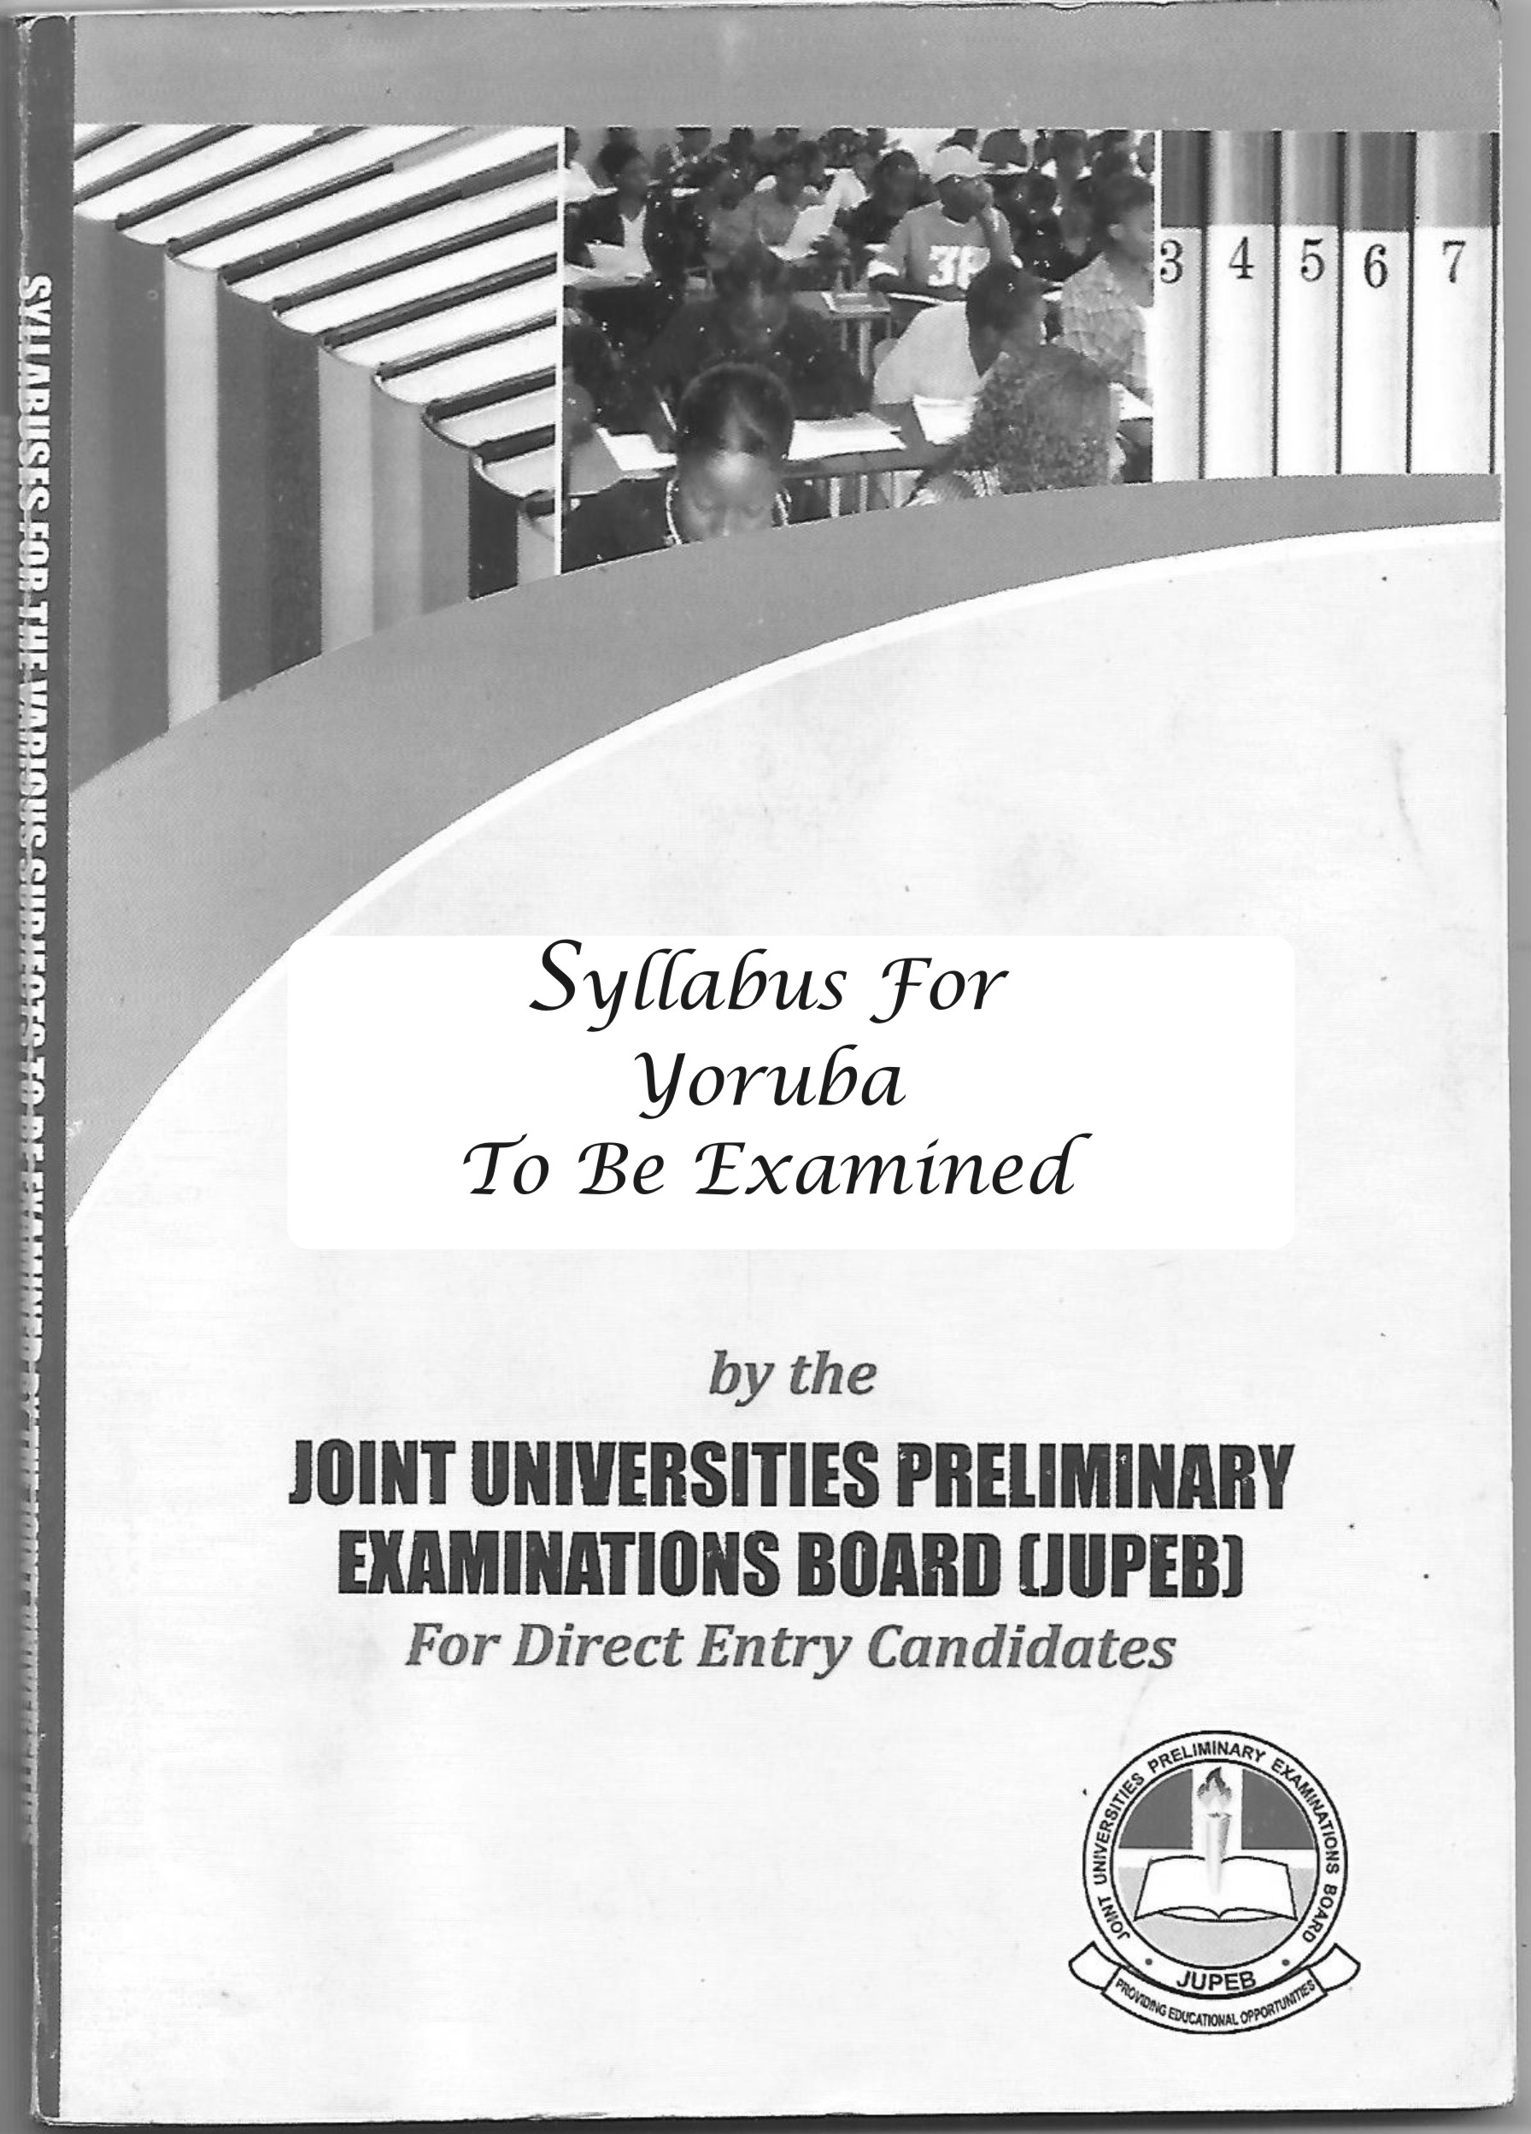
SYLLABUS FOR ART – J129
YORUBA
OBJECTIVES
At the end of this course, candidates should be able to:
- Classify speech sounds into their natural classes
- Discuss the phonological processes speech sounds may undergo in utterance
- Describe the Yoruba lexical categories and their syntactic distribution
- Discuss features of both oral and written Yoruba literature (drama, poetry and prose)
Structure of the syllabus
The syllabus is divided into four courses as follows:

First semester courses
YOR 001: language I: Yoruba phonology 3 Unit
YOR 003: literature I: Yoruba Literature 3 Unit

Second semester courses
YOR 002: language II: Yoruba grammar 3 Unit
YOR 004: literature II: written Yoruba literature 3 Unit

Course description
YOR 001: LANGUAGE I: YORUBA PHONOLOGY 3 Unit
This is an introduction to the scope of phonology comprising a preliminary treatment of Yoruba speech sounds – vowels and consonants; Yoruba syllable structure. It also focuses on the sounds system and the phonological processes such as vowel harmony, vowel assimilation, vowel coalescence and deletion that take place when they are found in utterances. It exposes students to Yoruba tones and both phonetic and phonemic transcription of Yoruba words. The focus of this course is on the sounds system and the phonological processes that take place when they are found in utterances.

Course contents
- Vowels, consonants and syllabic nasal
The four parameters of classification” place of articulation, manner of application, state of the glottis and what operates in the nasal cavity
- Syllable structure types: V, CV and N
- Phonological processes: vowel harmony, assimilation, deletion, coalescence etc.
- Tone (phonetic and non-phonemic), tonal change etc.
- Acculturation of loan words to Yoruba

YOR 002: LANGUAGE II: YORUBA GRAMMAR 3 Unit
An introductory study of the Yoruba grammar comprising Yoruba lexical categories (noun, verb adjectives etc) the Yoruba phrase and sentence with focus on its structure (simple, compound and complex sentence) and function (declarative, interrogative, exclamation etc). it also looks at the use of Yoruba enclitics and the distribution of nouns as subject, objects etc.

Course contents
The course is about word and sentence structure
- Word division lexical categories
- Noun
- Verb
- Adjectives
- Preposition, etc
- Word division non-lexical categories
- Modals
- Tense
- Aspects
- Word formation
- Affixation
- Duplication
- Compounding
- Sentence classification by structure
- Simple
- Compound
- Complex
- Sentence classification by function
- Declarative
- Interrogative
- Exclamation etc.
YOR 003: LITERATURE I: YORUBA ORAL LITERATURE 3 Unit
An introductory study of the nature and scope of oral Yoruba literature; its oral and transcribed forms, classification (poetry, prose, drama) and a preliminary study of each class type. Yoruba oral literature has three subdivisions which are poetry, prose, drama. Students are taken through a preliminary study of each class.
Course content
- Poetry: literary corpus: form (simile, metaphor, personification, hyperbole etc)
Contents (characterization, themes etc)
Ese ifa
Ijala
Iwi egungun/esa
Wkun iyawo
- Prose: Yoruba folklores (moral lessons)
Alo (apagbe ati apamo)
Owe
Aro
Imo
- Drama: Yoruba traditional drama
Orin ati ijo

YOR 004: LITERATURE II: YORUBA WRITTEN LITERATURE 3 Unit
A preliminary study of various written Yoruba literature: poetry, prose and drama exemplified by selected works of early authors.
Course contents
Yoruba written literature also divides into three poetry, prose and drama
- Ewi ajemo iselu
Ewi ajemo ise
Ewi ajemo asa
Ewi ajemo iwa omoluabi
Ewi ajemo ikilo
Ewi ajemo esin
- Prose: Prescribed texts of early Yoruba novels
- Drama: prescribed texts of early Yoruba drama
Ajemo iselu (Politically related drama)
Ajemo iwa ibaje (social ills related drama)

Selected texts
LANGUAGE
N | Author | Title | Publisher/Date
1 | Awobuluyi Oladele | Essentials of Yoruba grammar | UPL Ibadan 1978
2 | Awobuluyi Oladele | Eko iseda oro Yoruba | Montem Paper Backs
3 | Bamgbose Ayo | Fonoloji ati girama Yoruba 1 | UPL Ibadan 1991
4 | Ogunbowale P.A | Essentials of Yoruba language | UPL Ibadan 1970
5 | Owolabi Kola | Ijinle itupade ede Yoruba | Onibonoje press
6 | Adeniyi. H & A. Ojo | ilo-ede ati eda ede Yoruba | African World Press N Jersey 2005

ORAL LITERATURE
PROSE
N | Author | Title | Publisher/Date
1 | Babalola Adeboye | Akojopo Alo Ijapa I and II | UPL Ibadan 1985
2 | Babalola Adeboye | Orin Ode fun Aseye | Macmillan Ibadan 1969
3 | Ekun Iyawo

Jupeb.com.ng (JUPEB Alevel Registration) Thank You
www.jupeb.com.ng >>> JUPEB Foundation Programme Admission, Registration And Info Website
POETRY
N | Author | Title | Publisher/Date
1 | Salami Ayo | Ifa: A complete Divination | NIDD Publishers, Lagos 2005

WRITTEN LITERATURE
PROSE
N | Author | Title | Publisher/Date
1 | Thomas I.B | Itan Emi Segilola Eleyinju-ege | DB MARTOY Books Ibadan, 2010
2 | Fagunwa D.O | Ogboju Ode ninu Igbo Irunmola | Nelson Publisher, 1938

POETRY
N | Author | Title | Publisher/Date
1 | Obasa A. | Ewi Yoruba
2 | Arobiodu Sobo | Arofo Orin Sono Arobiodu

Drama
N | Author | Title | Publisher/Date
1 | Odunjo J.F | Agbalowomerii Baale jontolo
2 | Faleti A. | Basorun Gaa | Onibonoje publishers Ibadan 1972

Jupeb.com.ng (JUPEB Alevel Registration) Thank You
www.jupeb.com.ng >>> JUPEB Foundation Programme Admission, Registration And Info Website

